Project Title
Automated Network Request Management in ServiceNow

Name : Dheergasi Sameera
College : Aditya Institute of Technology and Management
Email : 23a51a12e4@adityatekkali.edu.in

Project Report

Date | 28/06/2026
Project Name | Automated Network Request Management

Project Overview
The Automated Network Request Management project in ServiceNow is developed to improve and automate the handling of network-related service requests within an organization. Businesses regularly receive requests for services such as network access, VPN activation, IP address allocation, device configuration, and troubleshooting connectivity issues. Managing these requests manually can lead to processing delays, inconsistent approvals, and limited visibility into the overall request workflow.
This solution utilizes the ServiceNow platform to automate the complete lifecycle of network requests. Employees can submit their requests through the Service Catalog, where automated workflows verify the submitted information, initiate approval processes, generate the required records, send email notifications, and continuously update the request status with minimal manual effort.
The project integrates various ServiceNow components, including Service Catalog, Catalog Variables, UI Policies, Custom Tables, Flow Designer, Approval Management, and Email Notifications, to build a reliable and scalable request management system. By automating these activities, the solution enhances operational efficiency, improves the user experience, ensures compliance with organizational standards, and maintains a complete audit trail for every network service request.

Table of Contents
- Introduction
- Project Objectives
- Key Features
- Project Milestones
- ServiceNow Developer Setup
- Project Implementation in ServiceNow
- Screenshots of Output
- Conclusion

1. Introduction :
In today's organizations, a stable and secure network infrastructure is essential for supporting day-to-day business activities. Employees frequently raise requests for services such as network access, VPN connectivity, IP address assignment, router and switch configuration, network relocation, and onboarding of new devices. Handling these requests manually often requires considerable administrative effort and may result in delays, human errors, and inconsistent processing.
As businesses expand, the number of network service requests continues to grow, making manual management increasingly inefficient. This can affect the timely resolution of requests, make it difficult to meet Service Level Agreements (SLAs), reduce visibility into request progress, and create inconsistencies in the approval process.
The Automated Network Request Management project, developed using the ServiceNow platform, provides a centralized and automated solution for managing network service requests. Users can easily submit requests through the Service Catalog, while automated workflows validate the submitted information, route requests for approval, create the necessary records, send notification emails, and track the request status throughout its lifecycle.
The proposed system offers the following benefits:
- Faster processing of network service requests
- Standardized and consistent workflow execution
- Reduced manual intervention and administrative workload
- Enhanced transparency throughout the request lifecycle
- Improved compliance with organizational policies
- Accurate monitoring and tracking of requests
- Increased user satisfaction through efficient service delivery
By utilizing the low-code capabilities of ServiceNow, this project demonstrates how IT Service Management (ITSM) can automate routine network service operations while providing flexibility for future enhancements and organizational growth.

2. Project Objectives :
The main objective of this project is to develop an automated Network Request Management System using the ServiceNow platform that reduces manual effort and improves the efficiency of handling network-related service requests. The system is designed to provide users with a simple and centralized platform for submitting requests, while automating the processes of validation, approval, record generation, notifications, and request tracking.
The project also focuses on building a standardized workflow that enhances service quality, increases operational efficiency, and ensures timely request fulfillment with minimal human intervention.
The specific objectives of this project are:
- Develop a centralized Service Catalog for submitting various network service requests.
- Design interactive request forms using Catalog Variables to capture the required information.
- Implement UI Policies to dynamically display or hide fields based on user input.
- Create Custom Tables to securely store and manage network request data.
- Configure Flow Designer to automate the complete request processing workflow.
- Establish automated approval mechanisms involving managers or network administrators.
- Generate email notifications automatically at different stages of the request lifecycle.
- Maintain detailed audit records for monitoring and tracking all submitted requests.
- Reduce request processing time while improving compliance with Service Level Agreements (SLAs).
- Build a scalable and flexible solution that can be extended to support additional network services in the future.

3. Key Features
The proposed system includes the following major features:
● User-friendly Service Catalog for submitting network requests.
● Dynamic forms with intelligent field visibility.
● Catalog Variables for capturing request information.
● Variable Sets for reusable user information.
● Automated approval workflows using Flow Designer.
● Custom Network Database table for request storage.
● Automatic creation of backend records.
● Email notifications during approval and completion stages.
● Real-time request status tracking.
● Audit-ready approval history.
● Scalable workflow architecture.
● Reduced manual processing time.

4. Project Milestones
The project implementation follows five major milestones.

Milestone 1: Catalog Creation
Objective
Establish a structured Service Catalog for network request management.
Activities:
● Identify different types of network requests.
● Create Service Catalog.
● Create Catalog Categories.
● Create Catalog Items.
● Provide meaningful names and descriptions.
● Organize request taxonomy according to ITSM standards.

Milestone 2: Form Setup
Objective
Design dynamic forms to collect all necessary request information.
Activities:
● Create Catalog Variables.
● Configure Variable Sets.
● Implement Catalog UI Policies.
● Configure mandatory fields.
● Apply field validation.
● Enable dynamic show/hide functionality.

Milestone 3: Approval Integration
Objective
Automate approval workflows before request fulfillment.
Activities:
● Configure approval hierarchy.
● Create Flow Designer approval actions.
● Implement manager approvals.
● Enable email notifications.
● Maintain approval audit logs.

Milestone 4: Testing
Objective
Validate the complete automation workflow.
Activities:
● Unit testing.
● Catalog testing.
● Flow testing.
● Approval testing.
● Notification testing.
● End-to-end request execution.
● User Acceptance Testing (UAT).

Milestone 5: Deployment
Objective
Deploy the application for organizational use.
Activities:
● Validate configurations.
● Publish catalog items.
● Monitor workflow execution.
● Train end users.
● Monitor post-deployment performance.

5. ServiceNow Developer Setup
Before developing the application, a ServiceNow Personal Developer Instance (PDI) must be created. The PDI provides a fully functional ServiceNow environment where applications can be developed, tested, and deployed without affecting production systems.

5.1 Creating a ServiceNow Developer Account :
To begin development, perform the following steps:
- Visit the ServiceNow Developer Portal.
- Click Sign Up to create a free developer account.
- Enter the required information:
○ First Name
○ Last Name
○ Email Address
○ Password
- Verify the email address using the activation link sent to your registered email.
- Log in to the ServiceNow Developer Portal.
- Click Start Building.
- Request a Personal Developer Instance (PDI).
- Wait for the instance to be provisioned.
- Launch the instance and log in using the generated credentials.

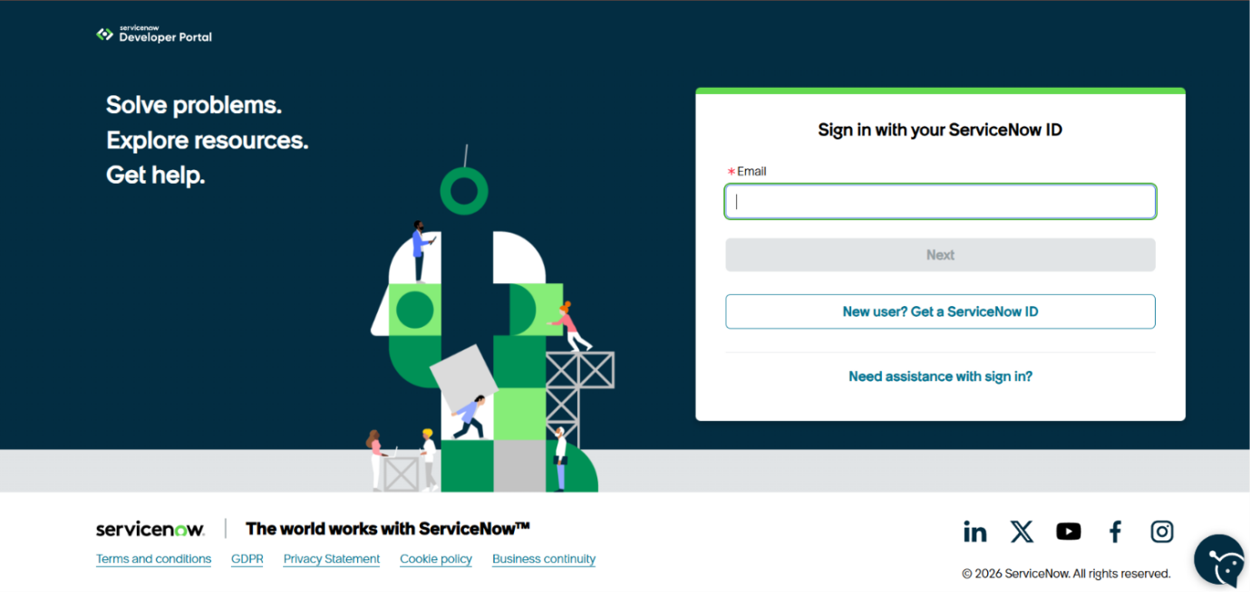

5.2 Accessing Creator Studio
Once the Personal Developer Instance is ready, ServiceNow redirects the developer to Creator Studio.
Creator Studio provides a no-code and low-code environment for building applications. It simplifies application development by allowing developers to create forms, workflows, tables, automation, and integrations through an intuitive graphical interface.

Creator Studio offers features such as:
● Application Creation
● Data Modeling
● Flow Automation
● Form Builder
● Catalog Item Development
● Workflow Configuration
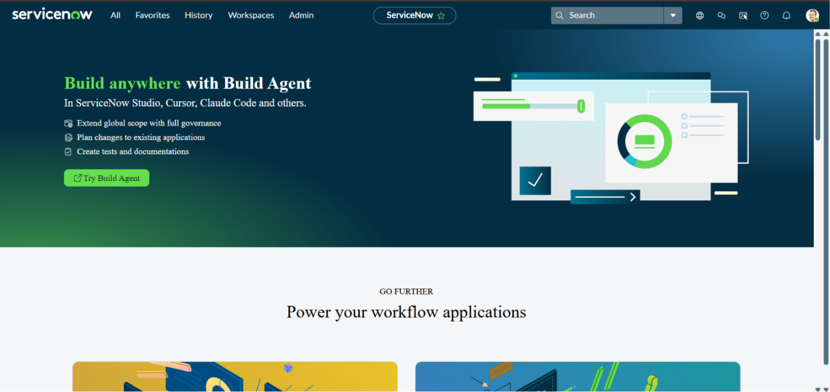

6.1 Service Catalog Creation
The Service Catalog acts as a centralized self-service portal that enables users to submit network service requests easily. In this project, a catalog item named Network Request was created to provide users with a single interface for requesting different network-related services such as VPN access, IP allocation, and device configuration.

Steps to Create the Service Catalog Item
- Open the Application Navigator in the ServiceNow platform.
- Search for Service Catalog.
- Navigate to the following path:
Service Catalog → Maintain Items
- Click the New button to create a new catalog item.
- Enter the required details:
  - Catalog Item Name: Network Request
  - Catalog: Service Catalog
  - Category: Network
  - Short Description: Automated Network Request Management
- Click Save to create and store the catalog item successfully.

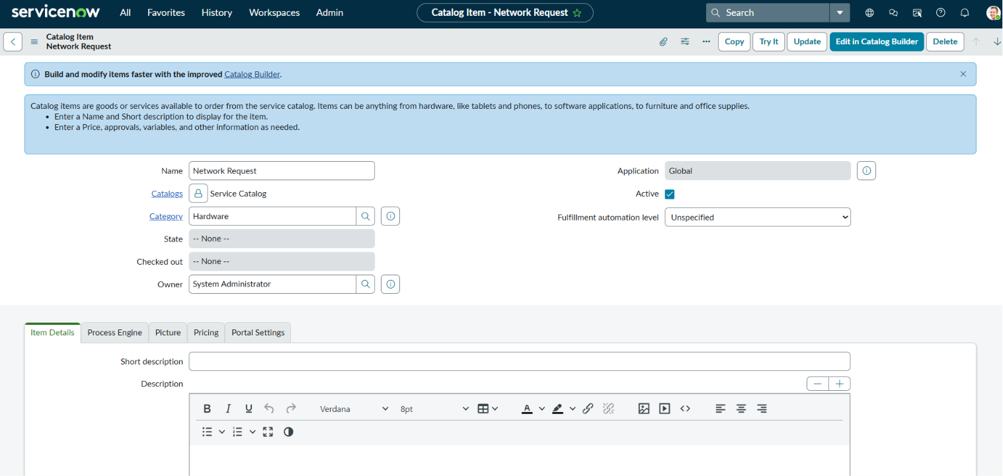

Purpose of the Catalog
The Service Catalog serves as the primary interface through which users can submit network-related service requests. It offers a centralized and user-friendly platform that standardizes the request submission process across the organization.
Using the Network Request catalog item, users can raise requests for services such as:
- New Network Connection
- Network Relocation
- Device Registration
- Network Configuration
- Connectivity Support
- Device Information Submission
By providing a single point of access for all network requests, the Service Catalog eliminates the need for manual email or phone-based requests, ensuring consistency, better tracking, and a more organized request management process.

6.2 Catalog Variables Configuration
Catalog Variables are used to collect the necessary information from users when they submit a network request. These variables appear as input fields on the Service Catalog form and capture the details required for processing and automating the request workflow.
The information entered through these variables is later utilized by Flow Designer, approval processes, and other automation components within the ServiceNow platform.

Steps to Create Catalog Variables
Follow the steps below to configure catalog variables:
- Open the Network Request catalog item.
- Navigate to the Variables related list.
- Click the New button to add a new variable.
- Configure the required properties, including:
  - Variable Type
  - Question
  - Name
  - Order
  - Tooltip
  - Help Text
  - Mandatory Status
- Click Save to create the variable.
Repeat the above procedure until all required catalog variables have been added to the Network Request catalog item.
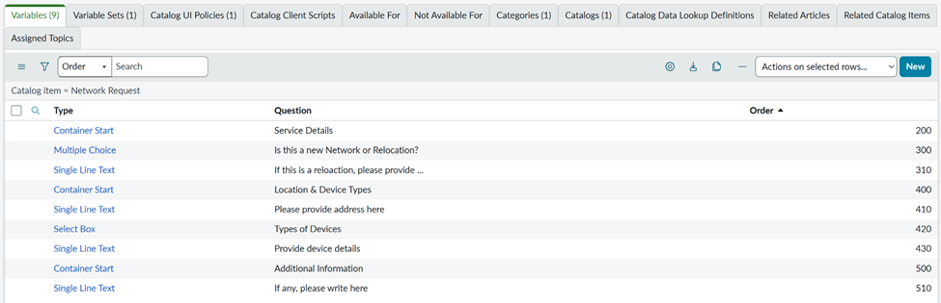

Variable Configuration
The Network Request catalog item consists of different types of variables to collect all the information required for processing a request. Each variable is selected based on the type of data that needs to be captured from the user.
Variable Name | Variable Type
Service Details | Container Start
Is this a New Network or Relocation? | Multiple Choice
If this is a relocation, please provide your previous location | Single Line Text
Location & Device Types | Container Start
Please provide the address here | Single Line Text
Types of Devices | Select Box
Provide Device Details | Single Line Text
Additional Information | Container Start
If any additional information, please provide here | Single Line Text

Types of Variables Used

1. Reference Variable
A Reference Variable is used to retrieve data from another ServiceNow table by referencing an existing record.
Example:
Opened On Behalf Of → User Table
This enables the system to automatically access user-related information, reducing manual data entry.

2. Choice Variable
A Choice Variable allows users to select one option from a predefined list of values.
Example:
Network Request Type
Available options include:
- New Connection
- Relocation
- Maintenance
- Configuration Change

3. Single Line Text
This variable type is used to capture short text values entered by the user.
Examples:
- Email Address
- Username
- Address
- Phone Number

4. Multi-Line Text
A Multi-Line Text variable is used whenever detailed information or explanations are required.
Example:
Device Details
Purpose:
Allows users to provide a complete description of the device, issue, or additional technical information.

5. Attachment Variable
The Attachment Variable enables users to upload supporting documents along with their request.
Some examples include:
- Identity Proof
- Device Purchase Invoice
- Approval Documents
- Other supporting files

Auto-Populated Variables
To improve efficiency, several fields are automatically populated using the Dot Walking feature. Once the user selects the Opened On Behalf Of field, the system automatically retrieves related information from the User table.
The automatically populated fields include:
- Email Address
- Username
- Phone Number
This automation minimizes manual input, improves accuracy, and reduces the possibility of data entry errors.

Advantages of Catalog Variables
The use of Catalog Variables provides several benefits, including:
- Standardized collection of user information
- Improved accuracy of submitted data
- Simplified workflow automation
- Better reporting and record management
- Reduced manual verification and validation

6.3 Variable Set Configuration
A Variable Set is a reusable collection of catalog variables that can be attached to multiple catalog items. Instead of creating the same variables repeatedly, developers can create them once and reuse them wherever necessary, improving consistency and reducing development time.
Some commonly reused variables include:
- Opened On Behalf Of
- Email Address
- Username
- Phone Number
- Document Upload

Steps to Create a Variable Set
- Open the Application Navigator and navigate to:
Service Catalog → Variable Sets
- Click New to create a new Variable Set.
- Enter the required information:
  - Name
  - Description
- Add all the required variables to the Variable Set.
- Save the Variable Set.
- Associate the created Variable Set with the Network Request catalog item for reuse.
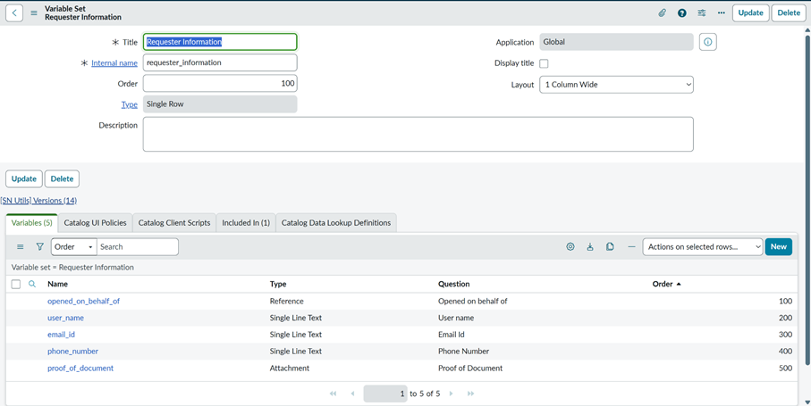

Advantages of Variable Sets
Using Variable Sets in the ServiceNow Service Catalog offers several benefits during application development and maintenance:
- Eliminates repetitive configuration by reusing common variables.
- Simplifies maintenance since updates are made in one place.
- Provides a consistent experience across multiple catalog items.
- Enables the same set of variables to be shared among different service requests.
- Reduces development time and improves implementation efficiency.

6.4 Catalog UI Policy Configuration
Catalog UI Policies are used to make catalog forms more interactive by controlling the visibility, mandatory status, and read-only behavior of variables based on user selections. These policies help create dynamic forms that display only the relevant fields required for a particular request.
In this project, Catalog UI Policies are configured to show or hide specific variables according to the network service selected by the user. This approach simplifies the form, reduces unnecessary data entry, and improves the overall user experience.

Objective
The implementation of Catalog UI Policies is intended to achieve the following objectives:
- Improve the usability and appearance of the request form.
- Minimize user confusion by displaying only relevant fields.
- Dynamically show or hide variables based on user selections.
- Make fields mandatory only when they are applicable.
- Prevent incomplete or incorrect request submissions.

Example Scenario
The UI Policies are configured to respond dynamically to user input.
For example:
- If the user selects Device Type = Others, an additional field named "Please Specify Device" is displayed.
- If the Request Type is selected as Relocation, the Relocation Address field becomes visible, allowing the user to enter the required location details.
This dynamic behavior ensures that users are presented only with fields relevant to their selected request.

Steps to Configure a Catalog UI Policy
- Open the Application Navigator and navigate to:
Service Catalog → Catalog Definitions → Maintain Items
- Open the Network Request catalog item.
- Scroll to the Catalog UI Policies related list.
- Click New to create a Catalog UI Policy.
- Enter the required details:
  - Applies To: Catalog Item
  - Catalog Item: Network Request
  - Description: Dynamic Field Visibility
- Configure the policy condition.
Example Condition:
  - Device Type = Others
- Save the Catalog UI Policy.
- Create a UI Policy Action.
- Select the variable Please Specify Device.
- Set the Visible property to True.
- Update and save the UI Policy.
- Open the Catalog Item and verify that the fields are displayed dynamically based on the selected conditions.
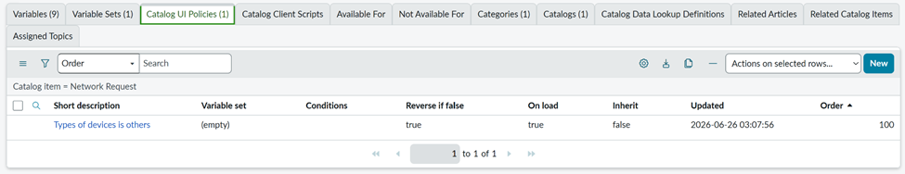

Benefits of UI Policies
Implementing Catalog UI Policies provides several advantages in improving the overall functionality and usability of the Service Catalog:
- Creates dynamic and interactive request forms.
- Enhances the overall user experience.
- Maintains a clean and organized interface by displaying only relevant fields.
- Minimizes validation errors during form submission.
- Improves the quality and accuracy of collected information.

6.5 Creation of Custom Table
A Custom Table was created in ServiceNow to maintain all network request records in a dedicated database. Rather than relying solely on catalog request records, this table stores complete request information, making it easier for administrators to manage, monitor, and generate reports.
Having a separate table also supports workflow automation, simplifies record management, and provides greater flexibility for future system enhancements.

Table Details
Table Name: Network Database
Purpose:
To store and manage all submitted network requests in a centralized location for tracking, reporting, and administrative purposes.

Steps to Create the Custom Table
- Open the Application Navigator.
- Navigate to:
System Definition → Tables
- Click New to create a table.
- Enter the required details:
  - Label
  - Table Name
  - Application
- Enable the Auto Generate Schema option.
- Click Submit to create the custom table.

Advantages of the Custom Table
The custom table offers several benefits, including:
- Centralized storage for all network request records.
- Simplified report generation and data analysis.
- Improved auditing and record tracking.
- Easy integration with future enhancements.
- Independent management of request-related data.

6.6 Field Creation
Once the custom table was created, the required fields were added to store the information collected through the Service Catalog. Each field in the table corresponds to a catalog variable, ensuring that all request details are stored systematically.
These fields act as the database structure used by workflows, reports, and administrative processes.

Steps to Create Table Fields
- Open the Network Database custom table.
- Navigate to the Columns tab.
- Click New to add a new field.
- Select the appropriate Field Type.
- Enter the Column Label.
- Specify the Column Name.
- Save the field.
Repeat these steps until all required fields have been added to the table.

Fields Created
Field Name | Data Type
Request Number | String
Requested For | Reference
Work Status | Choice
Device Type | Choice
Device Details | String
Customer Address | String
Assignment Group | Reference
Date of Enquiry | Date
Phone Number | String
Email ID | String
Approval Status | Choice

6.7 Flow Designer Implementation
Flow Designer is the primary automation component used in this project to manage the entire network request process. It automatically executes a sequence of predefined actions whenever a user submits a request through the Service Catalog. By automating tasks such as record creation, approval routing, email notifications, and status updates, the flow significantly reduces manual effort and improves the efficiency of request processing.
The automated workflow ensures that every request follows a consistent process from submission to completion while maintaining transparency and reducing processing time.

6.7.1 Flow Creation
The initial step in implementing automation is to create a new flow that controls the complete lifecycle of a network request. This flow serves as the central workflow responsible for coordinating all automated activities, including approvals, record updates, notifications, and other workflow actions.

Steps to Create the Flow
- Open the Application Navigator and search for Flow Designer.
- Launch Flow Designer.
- Click New and choose Flow.
- Enter the required details:
  - Flow Name: Network Request Management
  - Description: Automates the processing of network service requests.
- Click Build Flow to create the flow and begin configuring its automation logic.
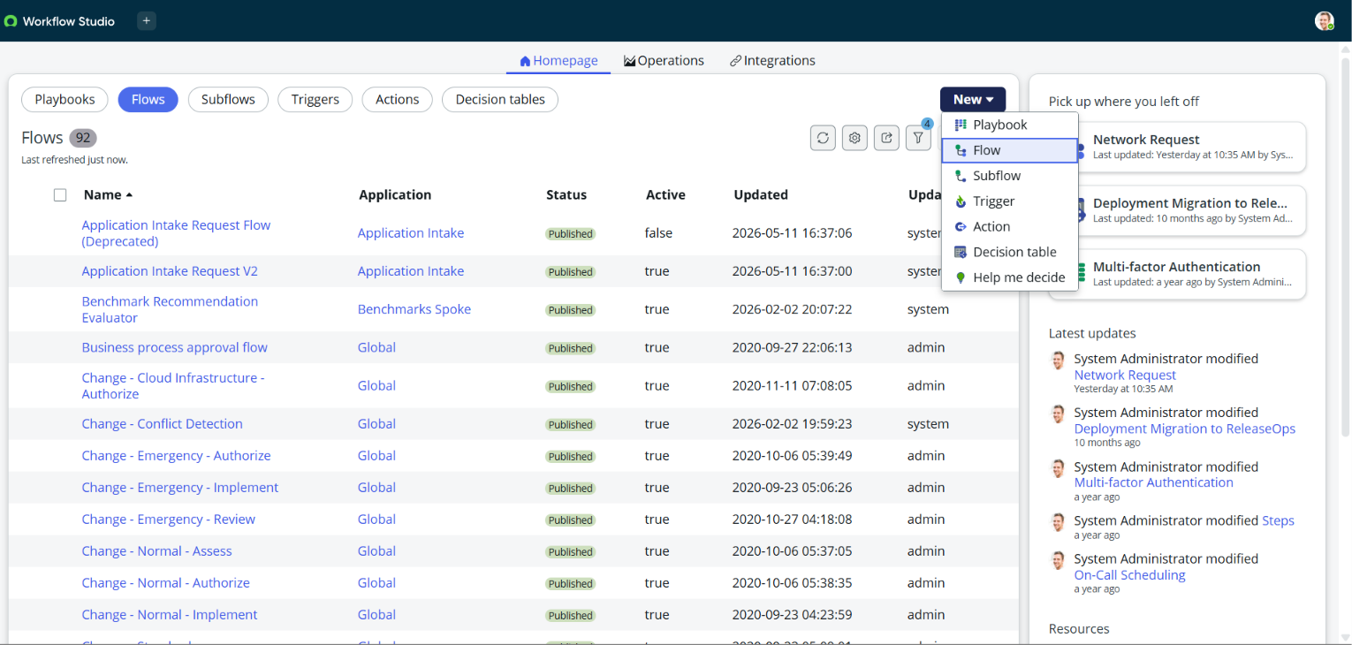

6.7.2 Configuring the Trigger
The Trigger specifies the event that initiates the execution of the flow. In this project, the flow is configured to start automatically whenever a user submits the Network Request catalog item through the Service Catalog.
This ensures that the automation process begins immediately after a request is created, eliminating the need for manual intervention.

Steps to Configure the Trigger
- Click the + (Add) icon in the Flow Designer.
- Select Trigger.
- Choose Service Catalog as the trigger type.
- Select Requested Item Created.
- Specify the Network Request catalog item.
- Save the trigger configuration.

6.7.3 Get Catalog Variables
After the flow is triggered, the next step is to retrieve the information entered by the requester. This is accomplished using the Get Catalog Variables action, which collects all the required input values from the submitted catalog item.
The retrieved data is then used throughout the workflow for record creation, approval processing, notifications, and other automated actions.

Steps to Configure Get Catalog Variables
- Click Add Action within the flow.
- Search for Get Catalog Variables.
- Select the Get Catalog Variables action.
- Configure the Requested Item as the input parameter.
- Choose all the required catalog variables.
- Save the action configuration.
The action retrieves important request details, including:
- Requested For
- Email ID
- Phone Number
- Device Type
- Device Details
- Address
- Request Type
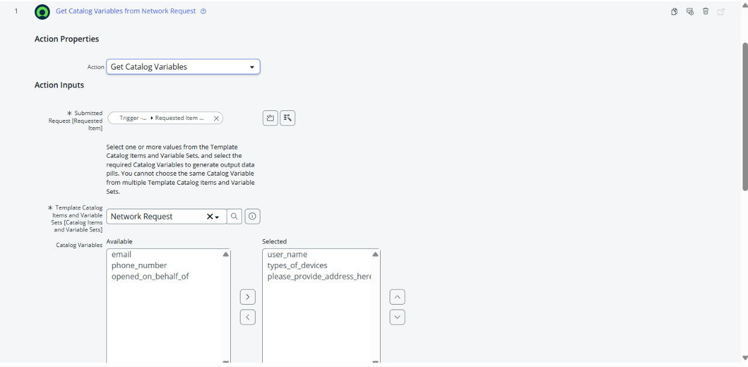

6.7.4 Create Record
Once the catalog variables have been retrieved, the next step is to create a new record in the Network Database custom table. The information collected from the Service Catalog is mapped to the corresponding fields in the table, ensuring that all request details are stored in a structured manner.
This record serves as the central source for tracking, managing, and processing network service requests throughout their lifecycle.

Steps to Configure the Create Record Action
- Click Add Action in the Flow Designer.
- Select the Create Record action.
- Choose the Network Database custom table.
- Map each catalog variable to its corresponding field in the table.
- Save the action configuration.
After the record is created successfully, all relevant request information is stored in the custom table, enabling administrators to monitor request status, generate reports, and efficiently manage network service requests.
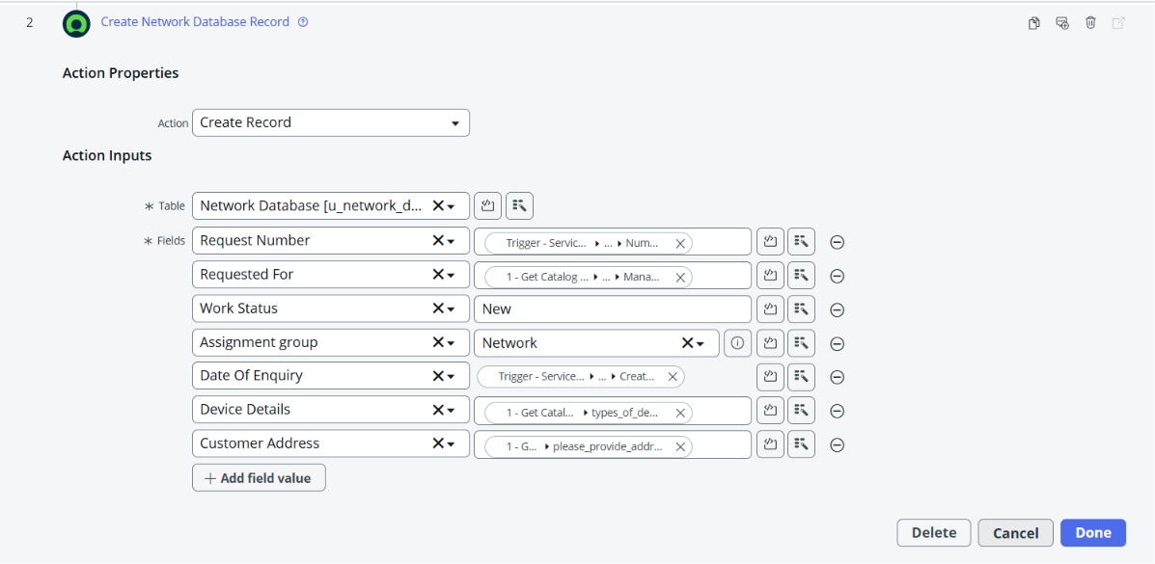

6.7.5 Approval Process
To ensure that network requests are processed only after proper authorization, an Approval Process is incorporated into the workflow. Once a request record is created, it is automatically forwarded to the designated approver, such as a Manager or Network Administrator, for review and decision.
This approval mechanism helps maintain organizational policies, improves accountability, and ensures that only valid requests proceed to the next stage of processing.

Steps to Configure the Approval Process
- Click Add Action in the Flow Designer.
- Select the Ask for Approval action.
- Choose the newly created Network Database record as the target record.
- Configure the required approval rule.
- Specify the appropriate approver (Manager or Network Administrator).
- Enter the approval reason and save the configuration.

Approval Outcomes
After the approver reviews the request, one of the following outcomes is recorded:
- Approved
- Rejected
- Pending
ServiceNow automatically records the approval history, including the approver's decision and status, providing a complete audit trail for every network request.

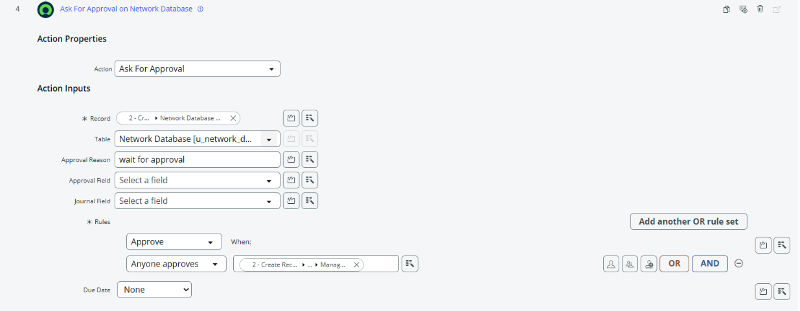

6.7.6 Flow Logic
The workflow uses conditional logic to determine the next set of actions based on the approval decision. After the approver reviews the request, the flow automatically follows the appropriate execution path, ensuring that each request is processed according to its approval status.

Approved Request
If the request receives approval, the flow performs the following actions:
- Sends an approval notification email to the requester.
- Updates the request status to Approved in the Network Database.
- Continues with the remaining request fulfillment process.

Rejected Request
If the request is rejected, the workflow performs these actions:
- Sends a rejection notification email to the requester.
- Changes the request status to Rejected.
- Stops any further processing of the request.
By implementing this decision-based logic, the workflow ensures that only authorized and approved network requests proceed to the execution stage, while rejected requests are closed with appropriate notifications and status updates.
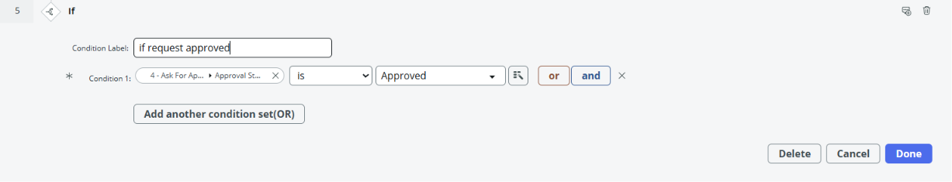

6.7.7 Email Notifications
To keep users updated throughout the request lifecycle, the system generates automatic email notifications at key stages of the workflow. These notifications provide timely updates about the current status of the network request, improving communication between users and administrators.
Email notifications are triggered during the following stages:
- Request Submitted
- Approval Pending
- Request Approved
- Request Rejected
- Request Completed
Each notification includes essential request information, such as the request details and its current status. This ensures that users remain informed throughout the entire process, enhances transparency, and reduces the need for manual follow-up regarding request progress.
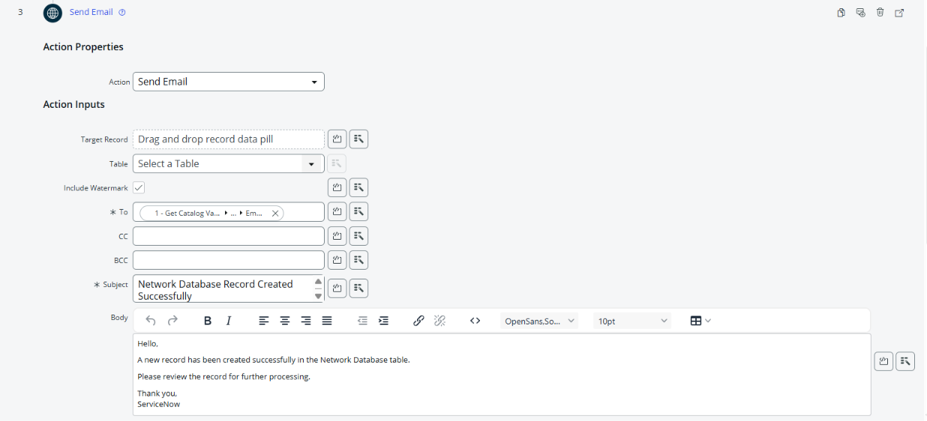

6.7.8 Update Record
After the approval process is completed, the corresponding entry in the Network Database custom table is updated automatically. The workflow modifies the record with the latest information so that the request status remains accurate throughout its lifecycle.
The system updates the following details:
- Approval Status
- Work Status
- Completion Date
- Assigned Team
By automatically updating these fields, the database always reflects the most recent progress of each network request. This ensures accurate record management, simplifies request tracking, and provides administrators with up-to-date information for monitoring and reporting purposes.
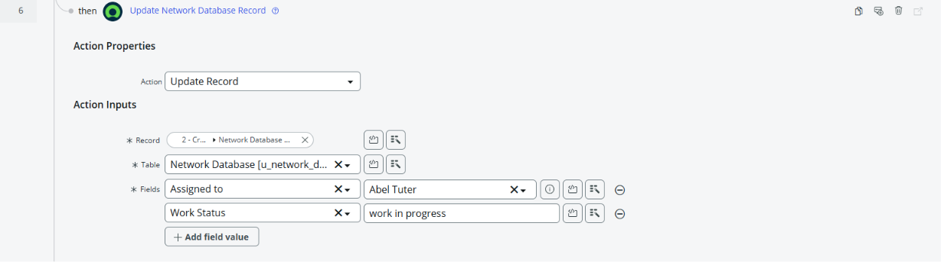

6.9 Workflow Summary
The following sequence outlines the complete workflow implemented in the Automated Network Request Management system. It demonstrates how a network request is processed from submission to completion using ServiceNow automation.
- The user submits a Network Request through the Service Catalog.
- The configured Flow Designer is automatically triggered upon request submission.
- The flow retrieves all required Catalog Variables entered by the user.
- A new record is generated in the Network Database custom table to store the request details.
- An approval request is automatically forwarded to the designated approver, such as a Manager or Network Administrator.
- The approver reviews the submitted request and records the approval decision.
- Based on the approval outcome:
  - Approved: The request continues to the fulfillment stage, and an approval notification is sent to the requester.
  - Rejected: The request is marked as rejected, the workflow stops further processing, and a rejection notification is sent to the requester.
- Finally, the corresponding record in the Network Database table is updated with the latest request status and other relevant details.

Flow Execution Test

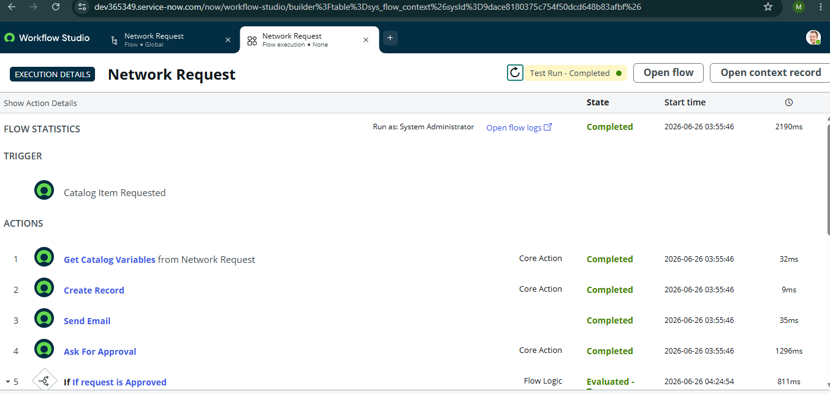
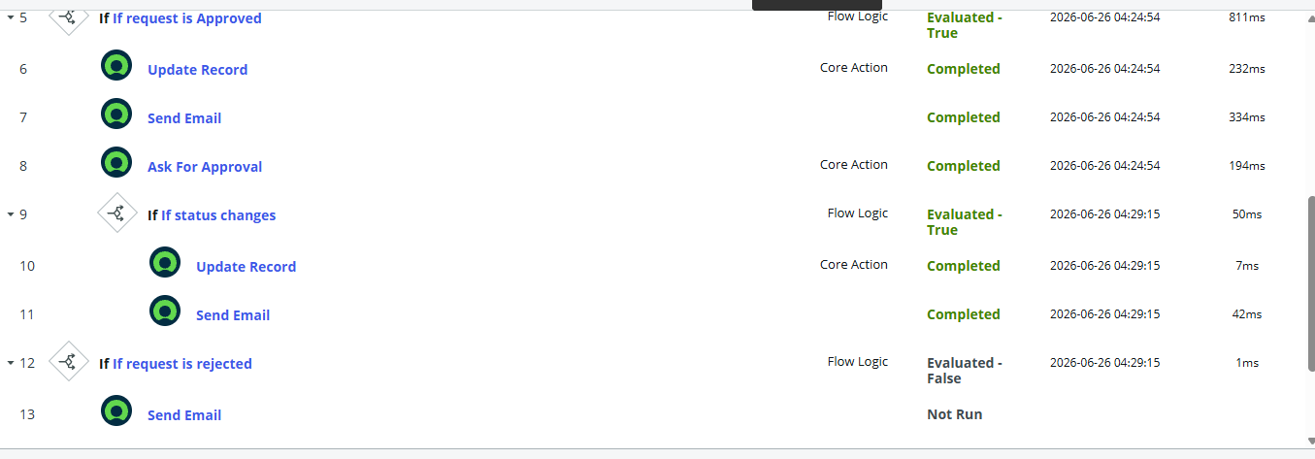

8 . Screenshots of Output
- Flow Designer View

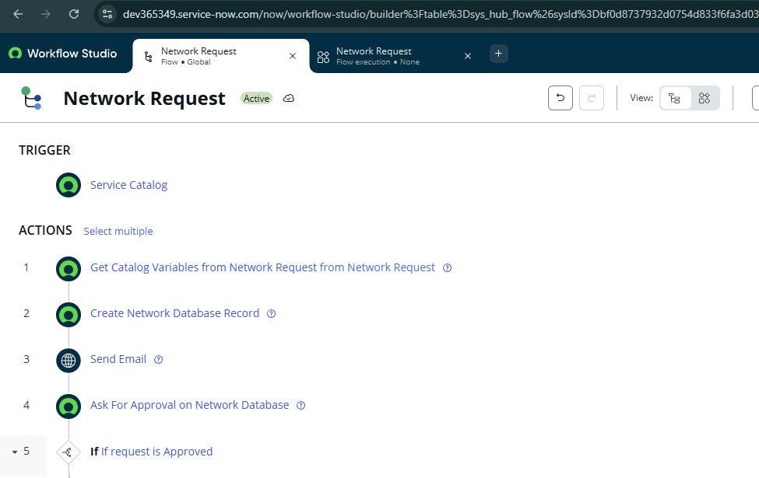
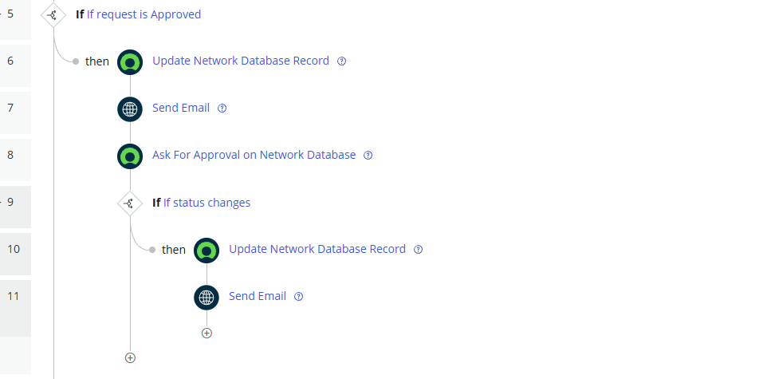

- Email Notification
Request REQ0010009 was created
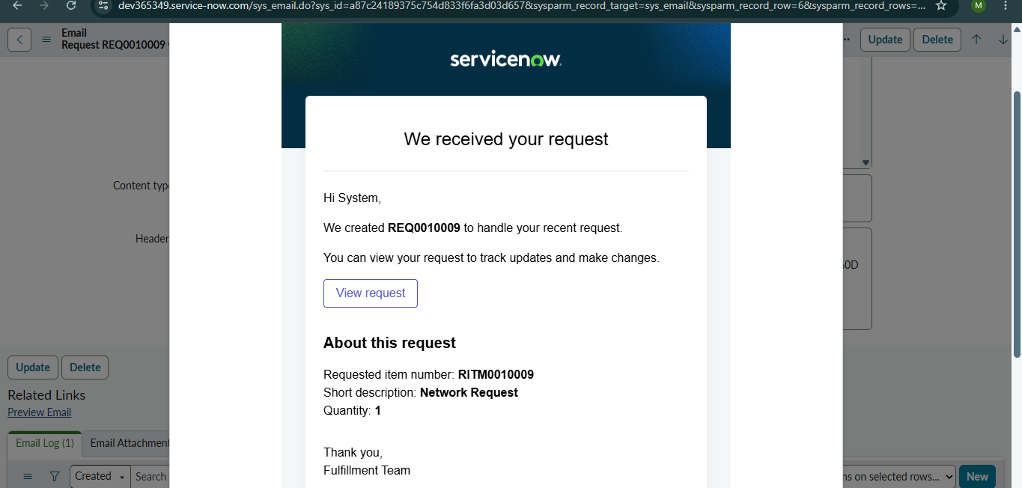

Request has been created
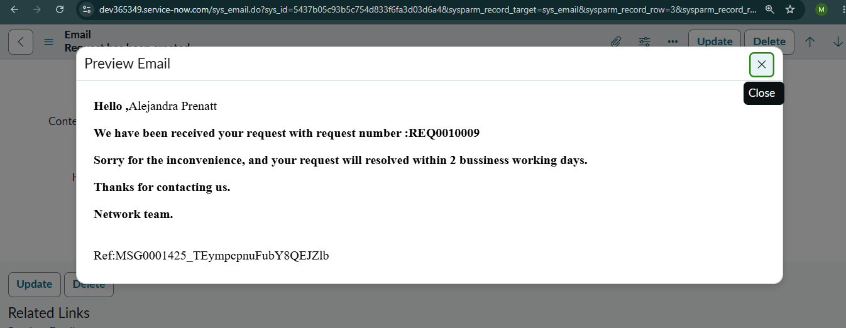

Network Request Approved
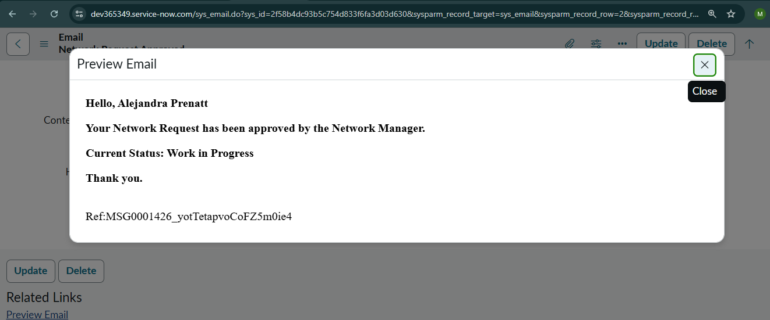

Network Request Completed
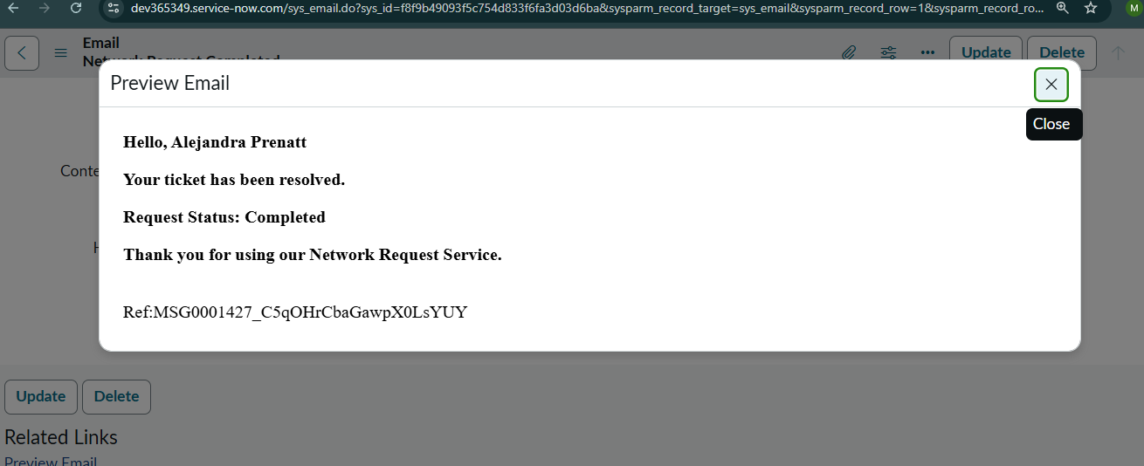

9 . Conclusion
The Automated Network Request Management project demonstrates the effectiveness of using the ServiceNow platform to automate and simplify the management of network service requests. By utilizing features such as the Service Catalog, Catalog Variables, UI Policies, Custom Tables, Flow Designer, Approval Management, and Email Notifications, the system provides a well-organized workflow that manages requests efficiently from submission through completion.
The automation implemented in this project reduces manual intervention, speeds up request processing, and ensures that every request follows a standardized workflow. Automated approvals, record management, and notification services improve communication, maintain accurate request tracking, and support compliance with organizational policies and Service Level Agreements (SLAs).
In conclusion, the project delivers a flexible, scalable, and user-friendly solution for managing network requests. It enhances operational efficiency, improves the overall user experience, and establishes a strong framework that can be extended in the future by integrating additional network services and advanced automation capabilities.

